CS-340-T5534 Client/Server Development 23EW5

4-1 Milestone: Create and Read in Python

Jacob Simmons, 28 May 2023

* **Importing a CSV file using the appropriate MongoDB import tool.**

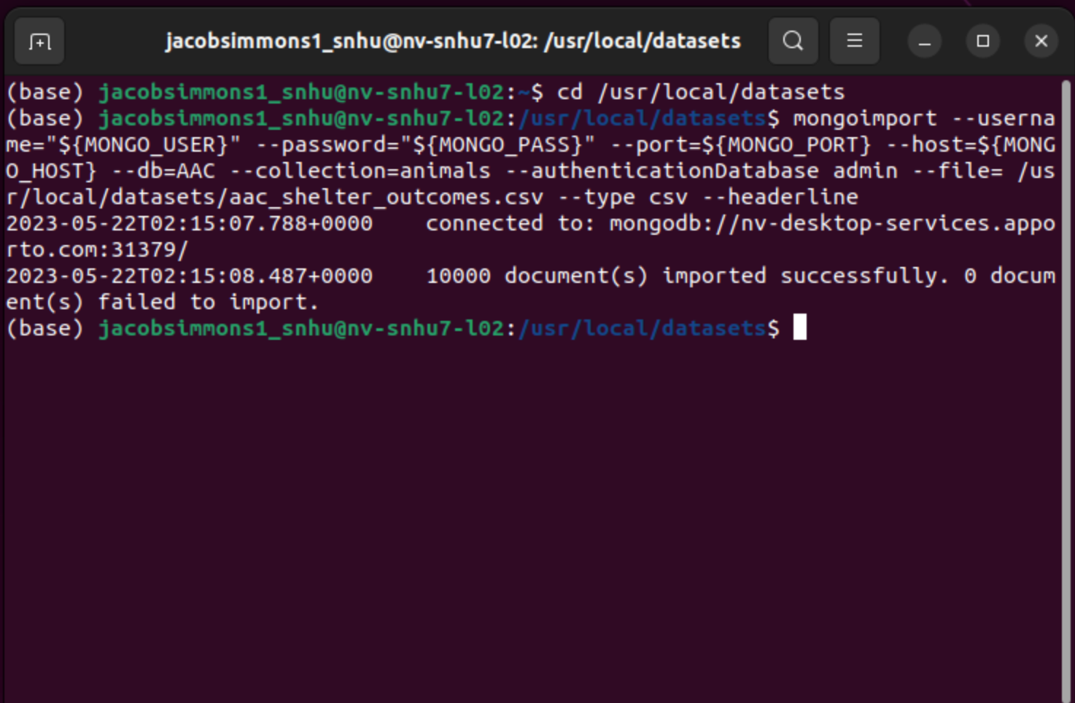

* **.py file that enable create and read functionality of the database.**
  + **Develop CRUD class**
    - **Develop a method that inserts document into specified MongoDB database and collection**
    - **Develop a method that queries for documents from a specified MongoDB database and collection**

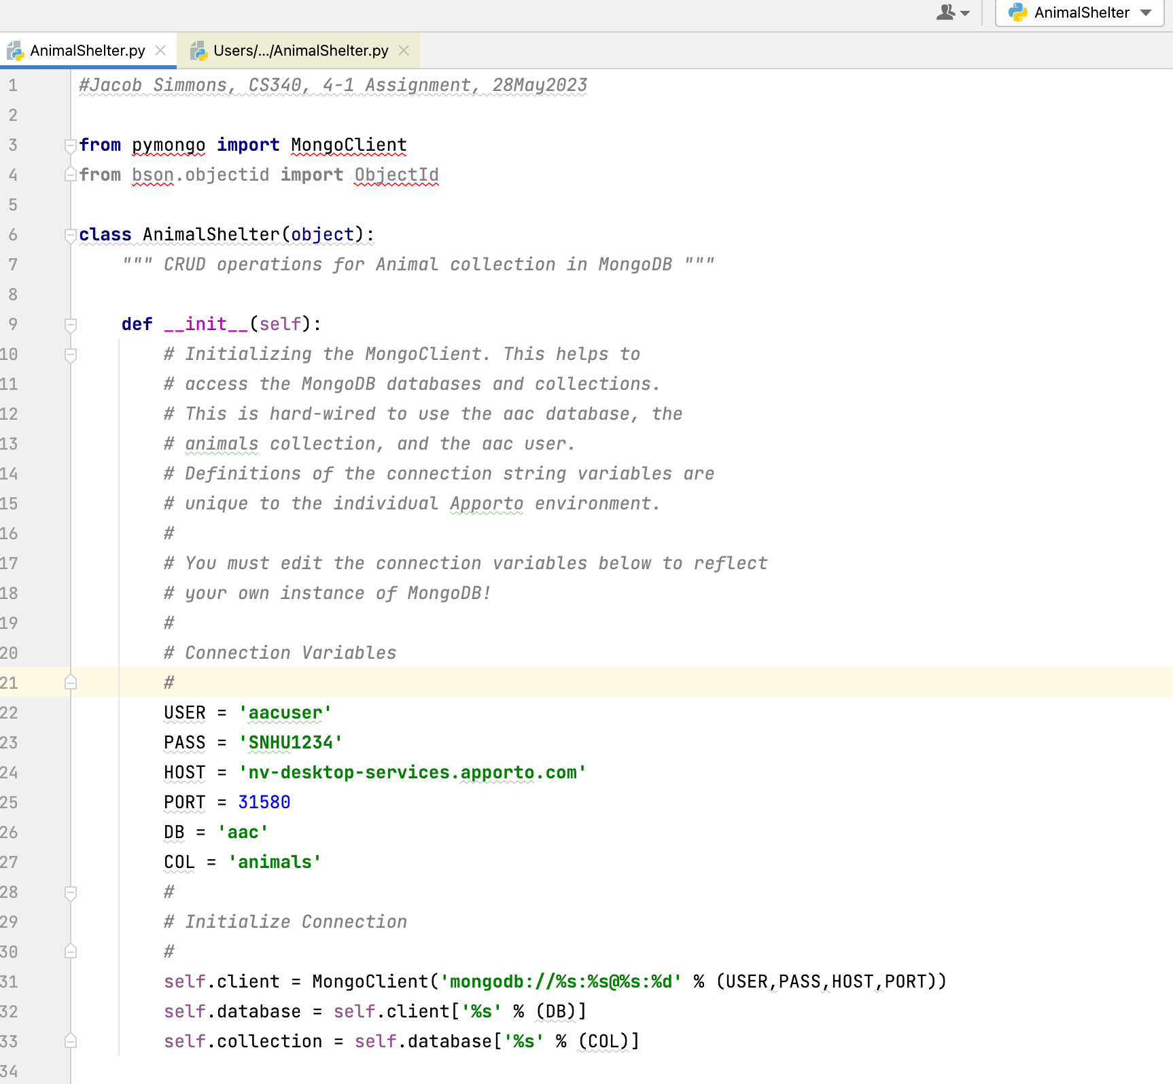

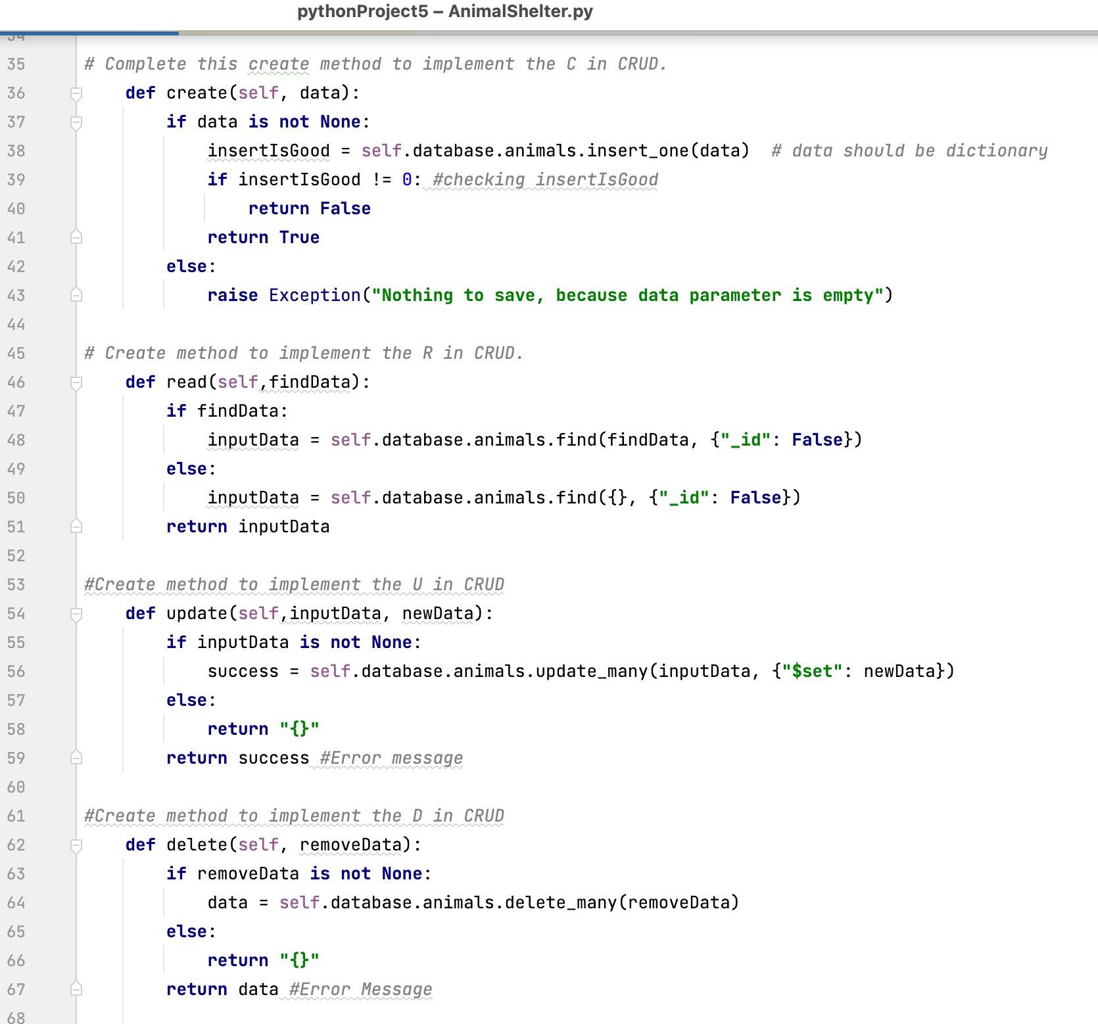

* **Create a Python testing script in Jupyter Notebooks that imports your CRUD Python module to call and test the create and read instances of CRUD functionality.**

I am running into issues setting up the Jupyter notebook correctly to have the instances and files link up appropriately for error checking. Below is what I have setup, and know the logic is there, but not certain how to link everything for error testing.

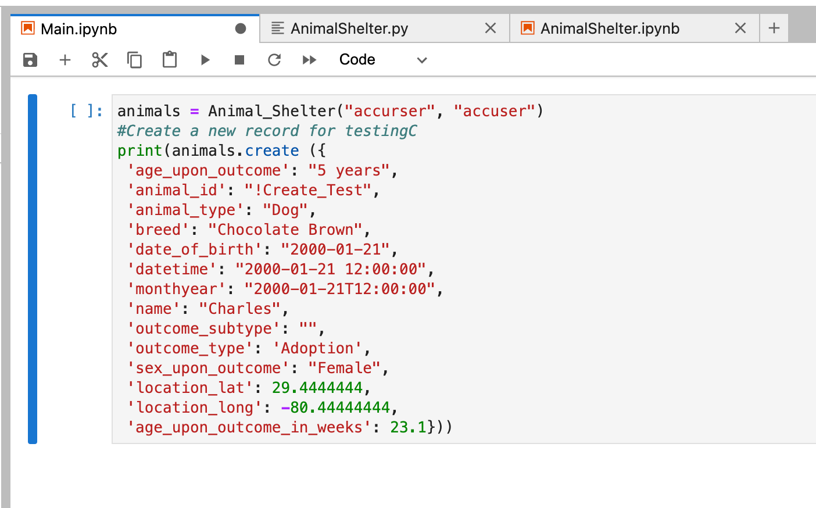

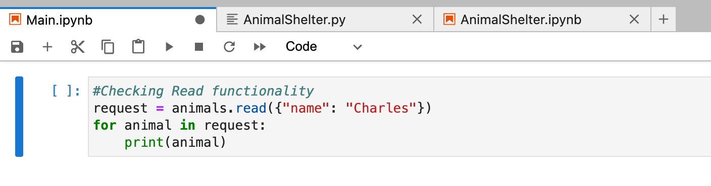

**References**

None